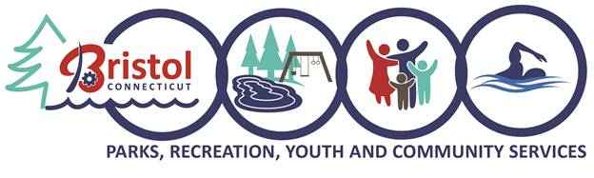

Bristol Parks and Recreational fields Crossword Puzzle
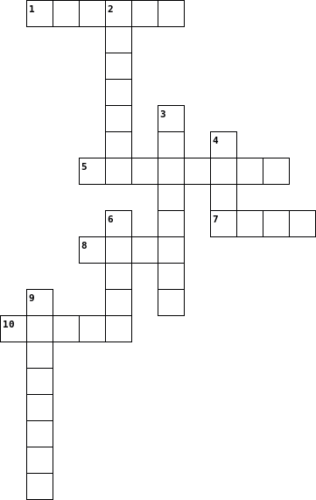

Across  1. Field Located on the corner of Burlington Avenue and Maple Avenue  5. Park The park features two entrances on School and North Main Streets.  7. This Park is approximately 22 acres and is located off Ivy Drive and Primrose Lane.  8. This Park entrances can be found off King Street, Moody Street, Page Avenue, and Woodland Street.  10. The Field was Given to the city in 1912 by Commissioner Adrian Muzzy in memory of his two sons |  | Down  2. This Park is located on Shrub Road next to Barnes Nature Center.  3. Park was given by Albert and Nettie Rockwell in 1911.  4. Park The softball field is located next to the playground. The field is fenced in.  6. The field is located in Lake Avenue.  9. Park Located on Broad Street forestville, CT
Answers
Across
- Nelson Field Located on the corner of Burlington Avenue and Maple Avenue
- Brackett Park The park features two entrances on School and North Main Streets.
- Kern Park is approximately 22 acres and is located off Ivy Drive and Primrose Lane.
- Page Park The entrances can be found off King Street, Moody Street, Page Avenue, and Woodland Street.
10. Muzzy Field The field was Given to the city in 1912 by Commissioner Adrian Muzzy in memory of his two sons

Down
- Seymour Park This Park is located on Shrub Road next to Barnes Nature Center.
- Rockwell Park This Park was given by Albert and Nettie Rockwell in 1911.
- Peck Park The softball field is located next to the playground. The field is fenced in.
- Casey Field The field is located in Lake Avenue.
- Quinlan Park Located on Broad Street Forestville, CT

